IT6711 - DATA MINING LABORATORY

IT6711 - DATA MINING LABORATORY
L T P C
0 0 3 2
OBJECTIVES:
The student should be made to:
- Be familiar with the algorithms of data mining
- Be acquainted with the tools and techniques used for Knowledge Discovery in Databases.
- Be exposed to web mining and text mining

LIST OF EXPERIMENTS:
1. Creation of a Data Warehouse.
2. Apriori Algorithm.
3. FP-Growth Algorithm.
4. K-means clustering.
5. One Hierarchical clustering algorithm.
6. Bayesian Classification.
7. Decision Tree.
8. Support Vector Machines.
9. Applications of classification for web mining.
10. Case Study on Text Mining or any commercial application.
TOTAL : 45 PERIODS
OUTCOMES:
After completing this course, the student will be able to:
- Apply data mining techniques and methods to large data sets
- Use data mining tools.
- Compare and contrast the various classifiers

LAB EQUIPMENT FOR A BATCH OF 30 STUDENTS:
SOFTWARE:
WEKA, RapidMiner, DB Miner or Equivalent
HARDWARE:
Standalone desktops 30 Nos

EX.no:1 APRIORI ALGORITHM
AIM:
To implement apriori algorithm to illustrate some basic element of association rule mining using weka.
PROCEDURE:
- Open excel and prepare data set and save as apriori.csv.
- Open weka tool and click tool tab.
- Select arff viewer and “apriori.csv” file
- Save it as arff file format.
- Close the tab.
- Open weka tool and click explorer button.
- Click “open” file button in preprocess tab and select “apriori.arff.”
- Remove transaction id field and select all fields.Goto “association” tab choose apriori .
- Click the “text “tab of apriori.
- set following parameters
-lower bound min support
-upper bound min support
-minmetric
-no.of.rules
- click start button .
- output is display .
OUTPUT:
=== Run information ===

Scheme: weka.associations.Apriori -I -N 10 -T 0 -C 0.8 -D 0.05 -U 0.22 -M 0.22 -S -1.0 -c -1
Relation: transaction
Instances: 9
Attributes: 5
i1
i2
i3
i4
i5
=== Associator model (full training set) ===

Apriori
=======
Minimum support: 0.22 (2 instances)
Minimum metric <confidence>: 0.8
Number of cycles performed: 16

Generated sets of large itemsets:

Size of set of large itemsetsL(1): 5

Large ItemsetsL(1):
i1=t 6
i2=t 7
i3=t 6
i4=t 2
i5=t 2

Size of set of large itemsetsL(2): 6

Large ItemsetsL(2):
i1=t i2=t 4
i1=t i3=t 4
i1=t i5=t 2
i2=t i3=t 4
i2=t i4=t 2
i2=t i5=t 2

Size of set of large itemsetsL(3): 2

Large ItemsetsL(3):
i1=t i2=t i3=t 2
i1=t i2=t i5=t 2

Best rules found:

1. i5=t 2 ==> i1=t 2 <conf:(1)> lift:(1.5) lev:(0.07) [0] conv:(0.67)
2. i4=t 2 ==> i2=t 2 <conf:(1)> lift:(1.29) lev:(0.05) [0] conv:(0.44)
3. i5=t 2 ==> i2=t 2 <conf:(1)> lift:(1.29) lev:(0.05) [0] conv:(0.44)
4. i2=t i5=t 2 ==> i1=t 2 <conf:(1)> lift:(1.5) lev:(0.07) [0] conv:(0.67)
5. i1=t i5=t 2 ==> i2=t 2 <conf:(1)> lift:(1.29) lev:(0.05) [0] conv:(0.44)
6. i5=t 2 ==> i1=t i2=t 2 <conf:(1)> lift:(2.25) lev:(0.12) [1] conv:(1.11)

RESULT:
Thus the experiment of the association rule mining using apriori algorithm is performed using weka-explorer has been executed successfully and verified

EX.NO:3 FP-GROWTH ALGORITHM

AIM:
To implement FP-growth algoritm to illustrate some basic elements of association rule mining using weka.
PROCEDURE:
- open excel and prepare dataset and save as FP-growth.
- openweka tool and clock tool tab.
- selectarff viewer and open “FP-growth.csv” file.
- save it as arff file format.
- close the tab.
- openweka tool and click “explorer” button.
- click “open” file button in preprocess tab and select all fields.
- Remove transaction id field and select all fields.
- goto association tab choose FP-growth.
- click the text tab of FP-growth.
- set following parameters
-lower bound min support
-upper bound min support
-minmetric
-no.of.rules
- click Start button.
OUTPUT:
=== Run information ===

Scheme: weka.associations.FPGrowth -P 2 -I -1 -N 10 -T 0 -C 0.8 -D 0.05 -U 0.22 -M 0.22
Relation: transaction
Instances: 9
Attributes: 5
i1
i2
i3
i4
i5
=== Associator model (full training set) ===
FPGrowth found 6 rules (displaying top 6)
1. [i5=t]: 2 ==> [i2=t]: 2 <conf:(1)> lift:(1.29) lev:(0.05) conv:(0.44)
2. [i4=t]: 2 ==> [i2=t]: 2 <conf:(1)> lift:(1.29) lev:(0.05) conv:(0.44)
3. [i5=t]: 2 ==> [i1=t]: 2 <conf:(1)> lift:(1.5) lev:(0.07) conv:(0.67)
4. [i5=t]: 2 ==> [i2=t, i1=t]: 2 <conf:(1)> lift:(2.25) lev:(0.12) conv:(1.11)
5. [i2=t, i5=t]: 2 ==> [i1=t]: 2 <conf:(1)> lift:(1.5) lev:(0.07) conv:(0.67)
6. [i1=t, i5=t]: 2 ==> [i2=t]: 2 <conf:(1)> lift:(1.29) lev:(0.05) conv:(0.44)

RESULT:
Thus the experiment of the association rule mining using FP-algorithm is performed using weka-explorer has been executed successfully and verified.

EX.NO:4 K-MEANS CLUSTERING
AIM:
To implement k-means algorithm to illustrate some basic elements of cluster rule using weka.
PROCEDURE:
  - Run weka explorer and load the data file kmeans.arff in preprocessing interface.
  - Inorder to perform clustering select the “cluster tab” in explorer and click on “choose” button this stop results in a dropdown list of available clustering algorithms.
  - In this case we select “simple k-means” next click in “text button “to right of choose button to get popup window shown.
  - In this window we enter two on the no.of.cluster we leave the value of ‘seed” as it is.
  - The seed value is used in generating a random number which is used for internal assignment of clusters.
  - once the option have been specified we run clustering algorithm there we must have sure
  - PARAMETERS:
- that they are in cluster mode panel.
  - Distance Function:Euclidean distance
  - Initialisationmethod:Random
  - Max iterations:10
  - Num clusters:3
- Seed:10
=== Run information ===
Scheme: weka.clusterers.SimpleKMeans -init 0 -max-candidates 100 -periodic-pruning 10000 -min-density 2.0 -t1 -1.25 -t2 -1.0 -N 2 -A "weka.core.EuclideanDistance -R first-last" -I 500 -num-slots 1 -S 10
Relation: kmeans
Instances: 9
Attributes: 1
k means
Test mode: evaluate on training data
=== Clustering model (full training set) ===
kMeans
======
Number of iterations: 4
Within cluster sum of squared errors: 0.1913265306122449
Initial starting points (random):
Cluster 0: 2
Cluster 1: 12
Missing values globally replaced with mean/mode
Final cluster centroids:
Cluster#
Attribute Full Data 0 1
(9.0) (6.0) (3.0)
============================================
k means 13 7 25
Time taken to build model (full training data) : 0 seconds
=== Model and evaluation on training set ===
Clustered Instances
0 6 ( 67%)
1 3 ( 33%)
RESULT:
Thus the experiment using k-means clustering algorithm is performed using weka-explorer was executed and verified.
EX.NO: 5 HIERARCHICAL CLUSTERING
AIM:
To illustrate use of single linkage hierarchical clustering alogorithm using weka.
PROCEDURE:
  - start the weka tool.
  - select the dataset and hierarchical clustering algorithm.
  - Begin with disjoint clustering having level L[0]=0,and sequence number m=0.
  - Find the least dissimilar of cluster at current clustering according to.
  - d[r,n]=min[d(i,j)]where m is overall pair of cluster.
  - Increment the sequence m=m+1 merge cluster r and n into a single cluster to form need clustering m
  - L(m)=d[(r),(s)]
  - update the proximity matrix D,by deleting the rows and columns corresponding to clusters (r)and(s) adding a rows and columns corresponding to newly formed cluster.
  - if all objects are in one cluster stop else goto step N.
  - start the algorithm.
  - store the result.
PARAMATERS: Euclidean distance
OUTPUT:
=== Run information ===
Scheme: weka.clusterers.HierarchicalClusterer -N 1 -L SINGLE -P -A "weka.core.EuclideanDistance -R first-last"
Relation: agg
Instances: 6
Attributes: 2
X
Y
Test mode: evaluate on training data
=== Clustering model (full training set) ===
Cluster 0
(0.53:0.63226,(((0.38:0.38853,0.41:0.38853):0.00465,(0.32:0.2766,0.3:0.2766):0.11658):0.05999,0.19:0.45317):0.17909)
Time taken to build model (full training data) : 0 seconds
=== Model and evaluation on training set ===

Clustered Instances
0 6 (100%)

RESULT:
Thus the experiment using one hierarchical clustering algorithm is performed using wekaexplorer was executed and verified.

EX.NO:6 BAYESIAN CLASSIFICATION

AIM:
To create the use of naive bayes classifier in weka. The sample data set used in this experiment is “weather”data available at arff format. This document assumes that appropriate data preprocessing has been performed.
PROCEDURE:
  - open excel and loading the data (climate.arff) into weka.
  - Next we select the “classify” tab and click “choose” button to select the “Naivebayes” classifier.
  - Now we specify the various parameters. These can be specified by clicking in the text box to the right of the choose button.
  - Under the “text “options in the main panel. We select the 10-fold cross validation as our evaluation approach.
  - we now click”start”to generate the model .
  - Note that the classification accuracy of model is about 69%.This indicates that we may find more work.
  - This can be done by right clicking the last result set and selecting “visualize tree” from the pop-up menu. We will use our model to classify the new instances.
  - In the main panel under “text “options click the “supplied test set” radio button
  - click the “set” button. This will show a popup window which will allow you to open the file containing test instances.
OUTPUT:

=== Run information ===
Scheme: weka.classifiers.bayes.NaiveBayes
Relation: weather-weka.filters.unsupervised.attribute.Remove-R1
Instances: 14
Attributes: 5
outlook
temperature
humidity
windy
play
Test mode: evaluate on training data

=== Classifier model (full training set) ===

Naive Bayes Classifier

Class
Attribute no yes
(0.38) (0.63)
=============================
outlook
rainy 4.0 3.0
overcast 1.0 5.0
sunny 3.0 4.0
[total] 8.0 12.0

temperature
hot 3.0 3.0
mild 3.0 5.0
cool 2.0 4.0
[total] 8.0 12.0

humidity
high 5.0 4.0
normal 2.0 7.0
[total] 7.0 11.0

windy
FALSE 3.0 7.0
TRUE 4.0 4.0
[total] 7.0 11.0

Time taken to build model: 0 seconds

=== Predictions on training set ===

inst# actual predicted error prediction
1 1:no1:no 0.704
2 1:no1:no 0.847
3 2:yes2:yes 0.737
4 2:yes2:yes 0.554
5 2:yes2:yes 0.867
6 1:no 2:yes + 0.737
7 2:yes2:yes 0.913
8 1:no1:no 0.588
9 2:yes2:yes 0.786
10 2:yes2:yes 0.845
11 2:yes2:yes 0.568
12 2:yes2:yes 0.667
13 2:yes2:yes 0.925
14 1:no1:no 0.652

=== Evaluation on training set ===

Time taken to test model on training data: 0.01 seconds

=== Summary ===

Correctly Classified Instances 13 92.8571 %
Incorrectly Classified Instances 1 7.1429 %
Kappa statistic 0.8372
Mean absolute error 0.2917
Root mean squared error 0.3392
Relative absolute error 62.8233 %
Root relative squared error 70.7422 %
Total Number of Instances 14

=== Detailed Accuracy By Class ===

TP Rate FP Rate Precision Recall F-Measure MCC ROC Area PRC Area Class
0.800 0.000 1.000 0.800 0.889 0.849 0.911 0.911 no
1.000 0.200 0.900 1.000 0.947 0.849 0.922 0.947 yes
Weighted Avg. 0.929 0.129 0.936 0.929 0.926 0.849 0.918 0.934

=== Confusion Matrix ===

a b <-- classified as
4 1 | a = no
0 9 | b = yes
=== Re-evaluation on test set ===
User supplied test set
Relation: weather-weka.filters.unsupervised.attribute.Remove-R1
Instances: unknown (yet). Reading incrementally
Attributes: 5
=== Predictions on user test set ===

inst# actual predicted error prediction
1 1:? 1:no 0.847
2 1:? 2:yes 0.554
3 1:? 2:yes 0.867
4 1:? 2:yes 0.737
5 1:? 2:yes 0.754
6 1:? 2:yes 0.568
7 1:? 2:yes 0.667
=== Summary ===

Total Number of Instances 0
Ignored Class Unknown Instances 7

=== Detailed Accuracy By Class ===

TP Rate FP Rate Precision Recall F-Measure MCC ROC Area PRC Area Class
? ? ? ? ? ? ? ? no
? ? ? ? ? ? ? ? yes
Weighted Avg. ? ? ? ? ? ? ? ?
=== Confusion Matrix ===
a b <-- classified as
0 0 | a = no
0 0 | b = yes

RESULT:
Thus the experiment using Bayesian classification algorithm is performed using wekaexplorer was executed and verified.

EX.NO:7 DECISION TREE
AIM:
To illustrate the use of “Decision tree” in weka..
PROCEDURE:
- open excel and loading the data (weather.arff) into weka.
- Next we select the “classify” tab and click “choose” button to select the”classifier.
- we specify the various parameters.
- These can be specified by clicking in the text box to the right of the choose button.
- Under the “text “options in the main panel.
- We select the 10-fold cross validation as our evaluation approach.
- Since wedon‟t have separate evaluation data set, this is necessary to get a reasonable idea of accuracy of generated model.
- we now click”start”to generate the model .
- This can be done by right clicking the last result set and selecting “visualize tree” from the pop-up menu.
- we will use our model to classify the new instances.
- In the main panel under “text “options click the “supplied test set” radio button.
- click the “set” button. This will show pop-up window which will allow you to open the file.
- Virtual tree is displayed the output screen.
OUTPUT:
=== Run information ===

Scheme: weka.classifiers.trees.j48.NaiveBayes
Relation: weather-weka.filters.unsupervised.attribute.Remove-R1
Instances: 14
Attributes: 5
outlook
temperature
humidity
windy
play
Test mode: evaluate on training data
=== Classifier model (full training set) ===
Naive Bayes Classifier
Class
Attribute no yes
(0.38) (0.63)
=============================
outlook
rainy 4.0 3.0
overcast 1.0 5.0
sunny 3.0 4.0
[total] 8.0 12.0

temperature
hot 3.0 3.0
mild 3.0 5.0
cool 2.0 4.0
[total] 8.0 12.0

humidity

high 5.0 4
normal 2.0 7.0
[total] 7.0 11.0

windy
FALSE 3.0 7.0
TRUE 4.0 4.0
[total] 7.0 11.0
Time taken to build model: 0 seconds
=== Predictions on training set ===
inst# actual predicted error prediction
1 1:no1:no 0.704
2 1:no1:no 0.847
3 2:yes2:yes 0.737
4 2:yes2:yes 0.554
5 2:yes2:yes 0.867
6 1:no 2:yes + 0.737
7 2:yes2:yes 0.913
8 1:no1:no 0.588
9 2:yes2:yes 0.786
10 2:yes2:yes 0.845
11 2:yes2:yes 0.568
12 2:yes2:yes 0.667
13 2:yes2:yes 0.925
14 1:no1:no 0.652
=== Evaluation on training set ===
Time taken to test model on training data: 0.01 seconds
=== Summary ===
Correctly Classified Instances 13 92.8571 %
Incorrectly Classified Instances 1 7.1429 %
Kappa statistic 0.8372
Mean absolute error 0.2917
Root mean squared error 0.3392
Relative absolute error 62.8233 %
Root relative squared error 70.7422 %
Total Number of Instances 14
=== Detailed Accuracy By Class ===
TP Rate FP Rate Precision Recall F-Measure MCC ROC Area PRC Area Class
0.800 0.000 1.000 0.800 0.889 0.849 0.911 0.911 no
1.000 0.200 0.900 1.000 0.947 0.849 0.922 0.947 yes
Weighted Avg. 0.929 0.129 0.936 0.929 0.926 0.849 0.918 0.934
=== Confusion Matrix ===
a b <-- classified as
4 1 | a = no
0 9 | b = yes
=== Re-evaluation on test set ===
User supplied test set
Relation: weather-weka.filters.unsupervised.attribute.Remove-R1
Instances: unknown (yet). Reading incrementally
Attributes: 5

=== Predictions on user test set ===

inst# actual predicted error prediction
1 1:? 1:no 0.847
2 1:? 2:yes 0.554
3 1:? 2:yes 0.867
4 1:? 2:yes 0.737
5 1:? 2:yes 0.754
6 1:? 2:yes 0.568
7 1:? 2:yes 0.667

=== Summary ===

Total Number of Instances 0
Ignored Class Unknown Instances 7

=== Detailed Accuracy By Class ===

TP Rate FP Rate Precision Recall F-Measure MCC ROC Area PRC Area Class
? ? ? ? ? ? ? ? no
? ? ? ? ? ? ? ? yes
Weighted Avg. ? ? ? ? ? ? ? ?

=== Confusion Matrix ===

a b <-- classified as
0 0 | a = no
0 0 | b = yes

RESULT:
Thus the experiment of ”Decision tree” algorithm is performed using weka-explorer was executed and verified.

EX.NO:8
SUPPORT VECTOR MACHINE

AIM:
To illustrates the use of support vector machines algorithm classifier in weka.
PROCEDURE:
- Open weka tool-click explorer in wekagul chooser.
- Now select arff viewer to change csv file to close the tab.
- click explorer button in menu bar.
- In preprocess tab click open file choose file name.
- goto classify tab-click choose button – select libsvm option.
- under the text option in the main panel,we select the 10-fold cross validation as our evaluation approach.
- click start button.
- output is displayed.

OUTPUT:
=== Run information ===
Scheme: weka.classifiers.functions.LibSVM -S 0 -K 2 -D 3 -G 0.0 -R 0.0 -N 0.5 -M 40.0 -C 1.0 -E 0.001 -P 0.1 -model "C:\\Program Files\\Weka-3-8" -seed 1
Relation: pima_diabetes
weka.filters.unsupervised.attribute.Normalize-S1.0-T0.0
Instances: 768
Attributes: 9
preg
plas
pres
skin
insu
mass
pedi
age
class
Test mode: 10-fold cross-validation
=== Classifier model (full training set) ===
LibSVM wrapper, original code by Yasser EL-Manzalawy (= WLSVM)
Time taken to build model: 0.09 seconds

=== Stratified cross-validation ===
=== Summary ===
Correctly Classified Instances 591 76.9531 %
Incorrectly Classified Instances 177 23.0469 %
Kappa statistic 0.4463
Mean absolute error 0.2305
Root mean squared error 0.4801
Relative absolute error 50.7075 %
Root relative squared error 100.7192 %
Total Number of Instances 768

=== Detailed Accuracy By Class ===

TP Rate FP Rate Precision Recall F-Measure MCC ROC Area PRC Area Class
0.920 0.511 0.771 0.920 0.839 0.468 0.704 0.761 tested_negative
0.489 0.080 0.766 0.489 0.597 0.468 0.704 0.553 tested_positive
Weighted Avg. 0.770 0.361 0.769 0.770 0.754 0.468 0.704 0.688

=== Confusion Matrix ===
a b <-- classified as
460 40 | a = tested_negative
137 131 | b = tested_positive
=== Re-evaluation on test set ===
User supplied test set
Relation: pima_diabetes-weka.filters.unsupervised.attribute.Normalize-S1.0-T0.0
Instances: unknown (yet). Reading incrementally
Attributes: 9
=== Predictions on user test set ===
inst# actual predicted error prediction
1 1:? 2:tested_positive 1
2 1:? 1:tested_negative 1
3 1:? 2:tested_positive 1
4 1:? 1:tested_negative 1
5 1:? 2:tested_positive 1
6 1:? 1:tested_negative 1
7 1:? 1:tested_negative 1
8 1:? 1:tested_negative 1
9 1:? 2:tested_positive 1
10 1:? 1:tested_negative 1
11 1:? 1:tested_negative 1
12 1:? 2:tested_positive 1
13 1:? 1:tested_negative 1
14 1:? 1:tested_negative 1
15 1:? 1:tested_negative 1

=== Summary ===
Total Number of Instances 0
Ignored Class Unknown Instances 15

=== Detailed Accuracy By Class ===
TP Rate FP Rate Precision Recall F-Measure MCC ROC Area PRC Area Class
? ? ? ? ? ? ? ? tested_negative
? ? ? ? ? ? ? ? tested_positive
Weighted Avg. ? ? ? ? ? ? ? ?
=== Confusion Matrix ===
a b <-- classified as
0 0 | a = tested_negative
0 0 | b = tested_positive

RESULT:
Thus the experiment of ”Support vector machine” algorithm is performed using wekaexplorer was executed and verified.

Ex.no:8 SPAM IDENTIFICATION

AIM:
To perform the spam identification using WEKA.
WEB MINING:
Web mining is application of data mining techniques to discover patterns from the World Wide Web .As the name proposes this is information gathered by mining the web .It makes utilization of automated approaches to reveal and extricate data servers web2 reports and it permits organization to get to both organized and unstructured information from browser activities server logs.
Web structure mining can also have another direction-directory the structure of web document itself.This type of structure of web pages ,this would be good for navigation purpose and make it possible to compare integrate web page schemas this type of structure mining will facilitate introducing database for accessing information in webpages.
Web mining can be divided into three different types .Web usage mining ,web contest mining and web structure mining.

VARIOUS CLASSIFIERS ARE USED:
Bayesian
Decision tree
Support vector machine
SPAM NOT SPAM:
Spam now also refers to secure e-mail or irrelevant posting to a newsgroup or bulletin board .The unsoliciated e-mail messages you receive about refinancing your home ,revensing aging and losing those extra pounds are all considered to be spam .Spamming other people is definitely not cool and is one of the most notorious violations of internet etiquette .So if you ever get the urge to let thousands of people know about that how new guaranteed way to make money on the internet, please reconsider.
SPAM IDENTIFICATION:
Spam e-mail becomes a big issue in e-mail communication .It cause continuous problems to the network administrator and security alert to prevent etiquette it effectively.
There are many types of techniques used in e-mail header spammer highlighted several information contained in the e-mail header that can be converted on forged to mislead the spam detection system .In this paper, we highlight several features contained in e-mail header that can be used to identify and classify spam message efficiently.

DATABASE DESCRIPTION:
Our collection of spam e-mail came from our postmaster and individuals who had filled spam our collection of non-spam e-mails came from fitted work and personal e-mail and hence the world “George” and the area code ‘650’ are indicators of non-spam .These are useful when constructing a personalized spam filter .One would either have to blind such non-spam indicators or get a very wide collection of non-spam to generate purpose spam filter.
ATTRIBUTE:57
48 -continuous real [0,100]word_freq_WORD
6 -continuous real[1,…] char_freq_CHAR
1 -continuous real[1,….]run_length_average
1 -continuous integer[1,….]run_length_longest
1-continuous integer [1,….]run_length_total
1-nominal{0,1}
Instances: 4601
PROCEDURE:
- Click ‘apply’ and save the normalize data in new folder.
- Select the select valued attribute choose infogainintoeval.choose ‘genetic search’ and then click start button.
- Thus the experiment is to find the high accuracy,so we can apply some classifier.Thus the classifier are Bayesian,Decision tree and SVM.
- We apply three classifier so decision tree is a high accuracy to be found in this experiment.
- So thus experiment is high accuracy of classifier(decision tree).

OUTPUT:
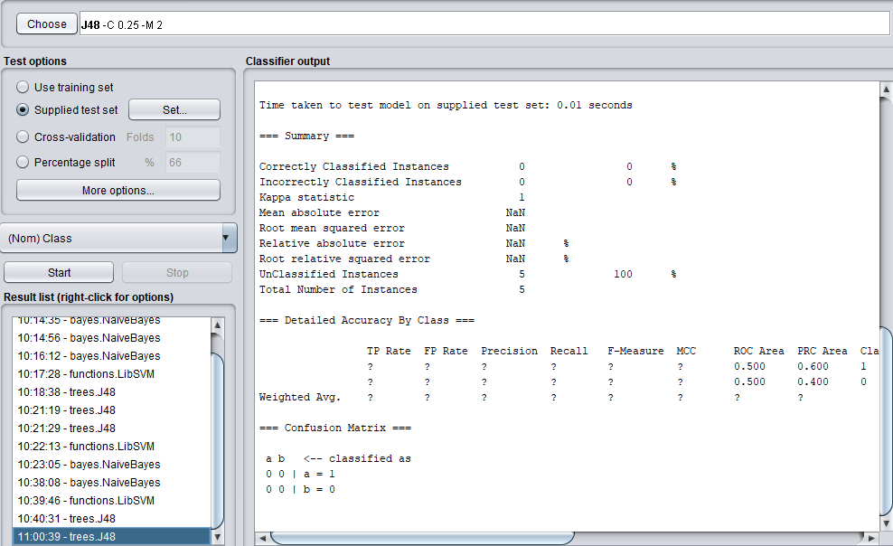

RESULT:
For spam identification of web mining we apply three different (SVM ,Decision tree, Naive Bayes) classifier. The Decision tree classifier is high accuracy is found in this experiment .Identification experiment is executed successfully.

EX.NO:9 DOCUMENT CLASSIFICATION

AIM:
To perform document classification using WEKA.
TEXT MINING:
It is the process of deriving high quality information that is typically derived through divising of patterns and trends.
VARIOUS CLASSIFIER USED:
- Bayesian
- Decision tree
- Support vector machine
DOCUMENT CLASSIFICATION:
Document classification is an ageold problem in information retreivaland it plays an important role in a varity of applications.
TOKENISATION:
Tokenisation is the act of breaking up a sequence of strings into pieces called tokens.
WORDCOUNT:
Word counter shows you the top 10 keywords and keyword density of article you are writing.
DATABASE DESCRIPTION:
The document were assembled and indexed with categories by personnel from renters.
PROCEDURE:
- Open Excel and prepare dataset and save it as CSV file
- Click WEKA Explorer in the WEKA menu
- Select preprossing click open file and select the dataset from it
- Apply normalize and save it as text.arff file
- Choose classify from the top and click choose to select the algorithms such as bayesian , decision tree and SVM.
- Select start button to produce the output
- Click te select value attribute and choose infogain into eval and choose ranker and then click start button
- these algorithms are used to find the high accuracy so we apply some classifier algorithms
- From these three outputs we obtain the high accuracy.
OUTPUT:
=== Run information ===

Scheme: weka.classifiers.trees.DecisionStump
Relation: spambase-weka.filters.unsupervised.attribute.Normalize-S1.0-T0.0-weka.filters.unsupervised.attribute.Normalize-S1.0-T0.0-weka.filters.unsupervised.attribute.Normalize-S1.0-T0.0-weka.filters.unsupervised.attribute.Remove-V-R2,31,35,58
Instances: 4601
Attributes: 4
word_freq_address
word_freq_telnet
word_freq_85
Class
Test mode: 10-fold cross-validation

=== Classifier model (full training set) ===

Decision Stump

Classifications

word_freq_address<= 0.005252 : 0
word_freq_address> 0.005252 : 1
word_freq_address is missing : 0

Class distributions

word_freq_address<= 0.005252
1 0
0.3215906058179877 0.6784093941820123
word_freq_address> 0.005252
1 0
0.711943793911007 0.28805620608899296
word_freq_address is missing
1 0
0.39404477287546186 0.6059552271245382

Time taken to build model: 0.01 seconds

=== Stratified cross-validation ===
=== Summary ===

Correctly Classified Instances 3147 68.3982 %
Incorrectly Classified Instances 1454 31.6018 %
Kappa statistic 0.2712
Mean absolute error 0.4319
Root mean squared error 0.4649
Relative absolute error 90.4312 %
Root relative squared error 95.1428 %
Total Number of Instances 4601

=== Detailed Accuracy By Class ===

TP Rate FP Rate Precision Recall F-Measure MCC ROC Area PRC Area Class
0.336 0.090 0.709 0.336 0.456 0.309 0.611 0.526 1
0.910 0.664 0.678 0.910 0.777 0.309 0.611 0.665 0
Weighted Avg. 0.684 0.438 0.690 0.684 0.651 0.309 0.611 0.610

=== Confusion Matrix ===

a b <-- classified as
609 1204 | a = 1
250 2538 | b = 0

RESULT :
Thus the document classification was performed successfully using WEKA tool.

EX.NO:10 CREATION OF DATAWAREHOUSE
AIM:
To create a datawarehouse using postgresql tool.
PROCEDURE:
- Click start-->all program -->postgresql 9.3 --> click pgAdmin3
- In the file,select new server enter valid name,port username and password and click ok
- Double click on the created server (localhost 5432)
- Expand the database(1) and choose --> new database and type the database name dwftp
- Expand the dwftp and click on schema(1) --> new schema.Type the schema name dw
- Then expand the dw --> tables(0)
- Click the sql icon and create four tablesdw.timedim,dw.phonerate,dw.location and dw.facts which is having the necessary attributes,primary and foreign keys
- Then we add datasets to the table by importing .CSV file
- Right click on the table name --> import and select the file
- We may also add and update table directly by view the table values
- 9.Click on SQL icon --> type the SQL queries with reference and click the run button
- 10. The output for the query will be displayed
Output:

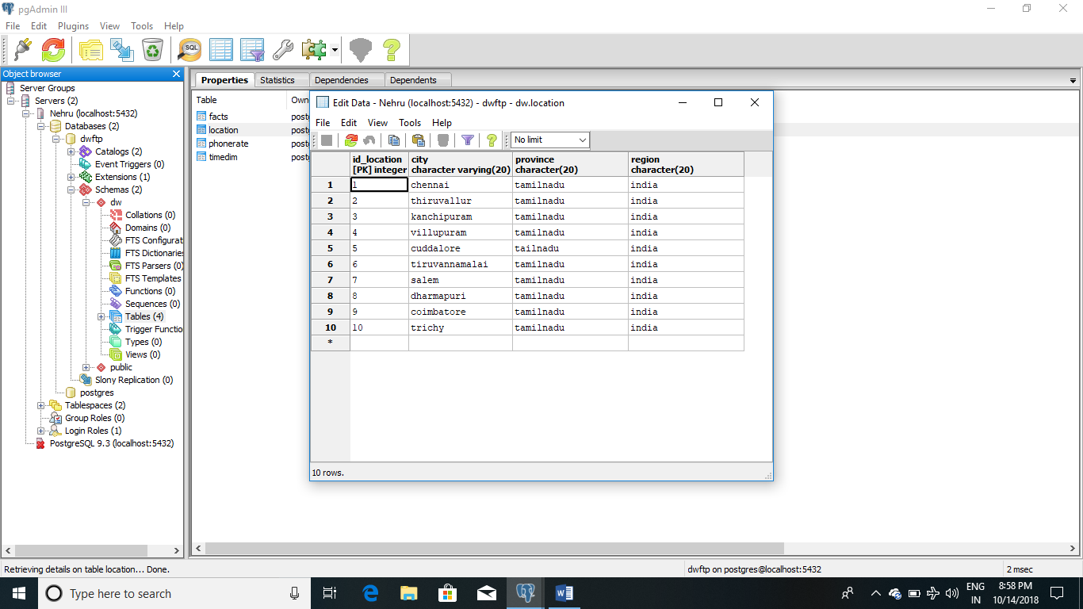

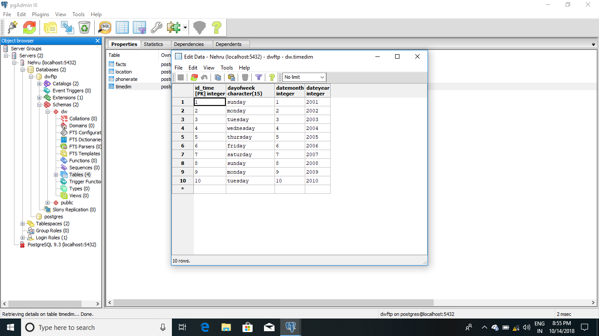
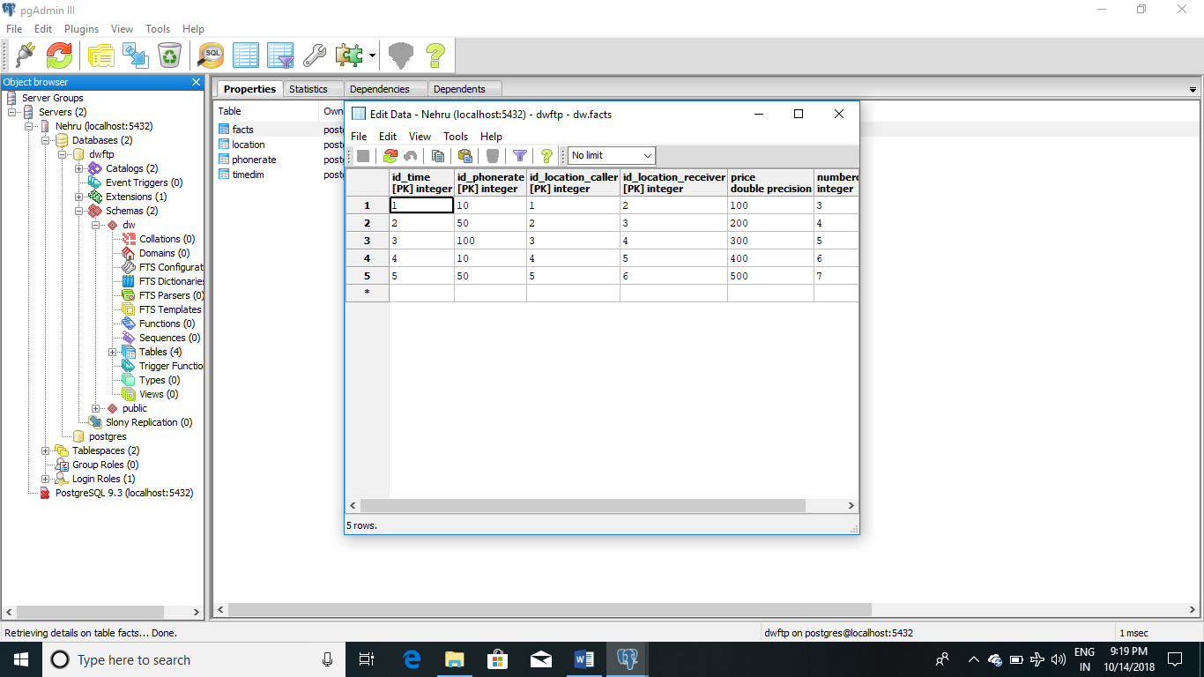

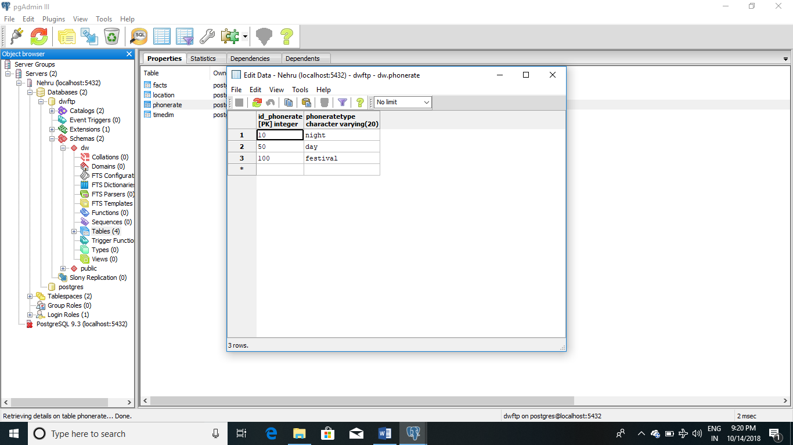

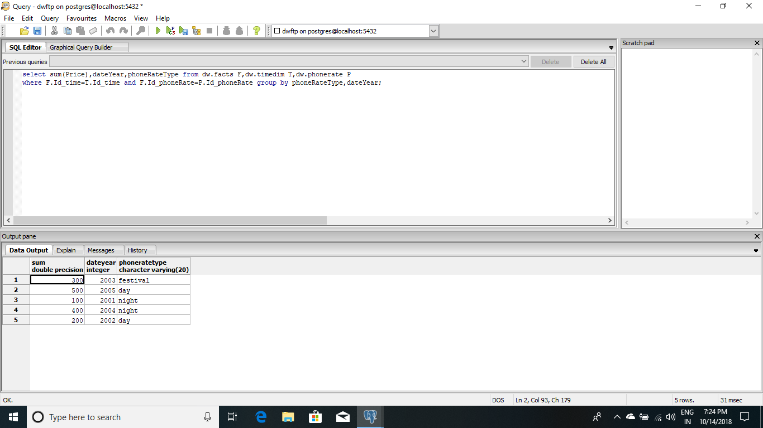

RESULT:
Thus the Data warehouse has been created using PostgreSQL tool.

